Mini Tube Car

Subject:  Related Subjects: | Grade Level(s):  Length of Lesson: | Type: Inquiry / Design / Project  Keywords:

Lesson Overview
Use this section to describe at a high level what the lesson is. Should be no more than 3-4 lines.

Lesson Focus
What is the central question or phenomenon being investigated? What problem are they trying to solve?

Lesson Objective(s) | By the end of this lesson, students will…  - Learn the concepts of attraction, repulsion, friction, polarity, and charge.

Lesson Timing

5 minutes | Introduce the Lesson
30 minutes | ...

Materials | Each Car  - 1 Tube (~8”)  - 2- 2AA battery holders stripped  - 2- motors  - 4- 5” red wires stripped  - 4-5” black wires stripped  - 6”x4” foam board  - DPDT (6 prong switches)  - 9”- 3/16” dowels  - 2- 10”-1/4” dowels  - 6- 3” paper cups  - 12- rubber bands  - 2- index cards  General supplies (per group of 5)  - 1-Rolls of tape  - 1- pair Scissors  - 1-Glue guns  - 1- Wire strippers  - 1-Xacto knives  - 1-Glue gun slugs  - 1-Pencils  - 2-AA Batteries
Instructor Prep | - Step 1
Related Resources | - List related lessons/ppts etc available from USC or outside, trusted orgs

Lesson Plan

Introduction

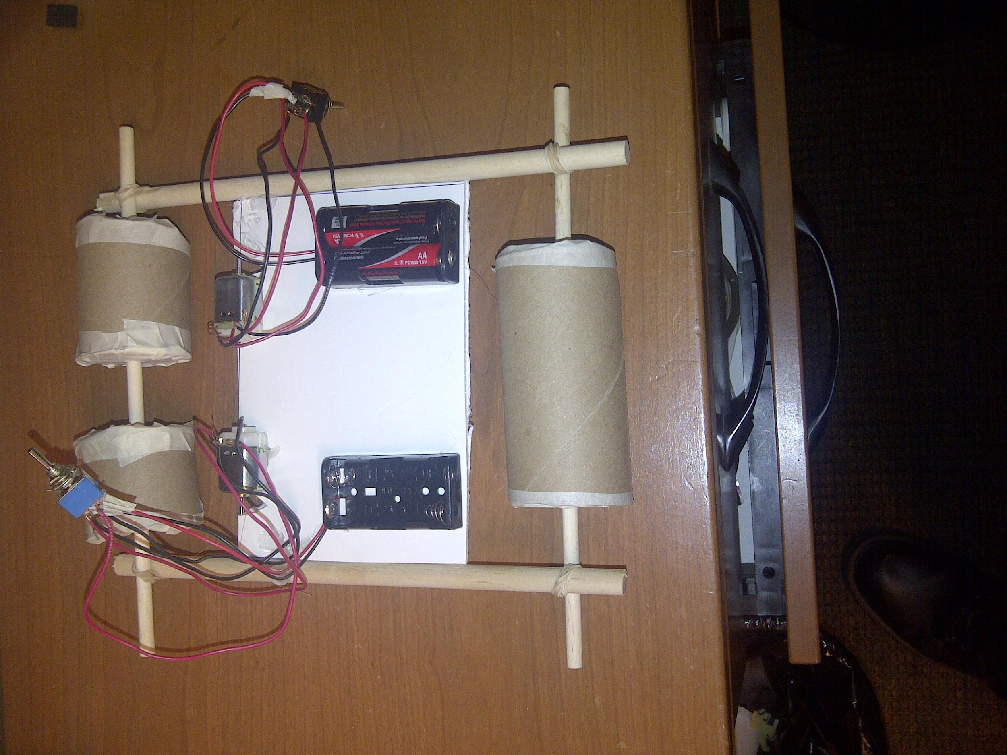
A series circuit is formed when an electrical source (battery) is connected to an object (motor, light…) which is connected to a switch which is connected back to the battery.
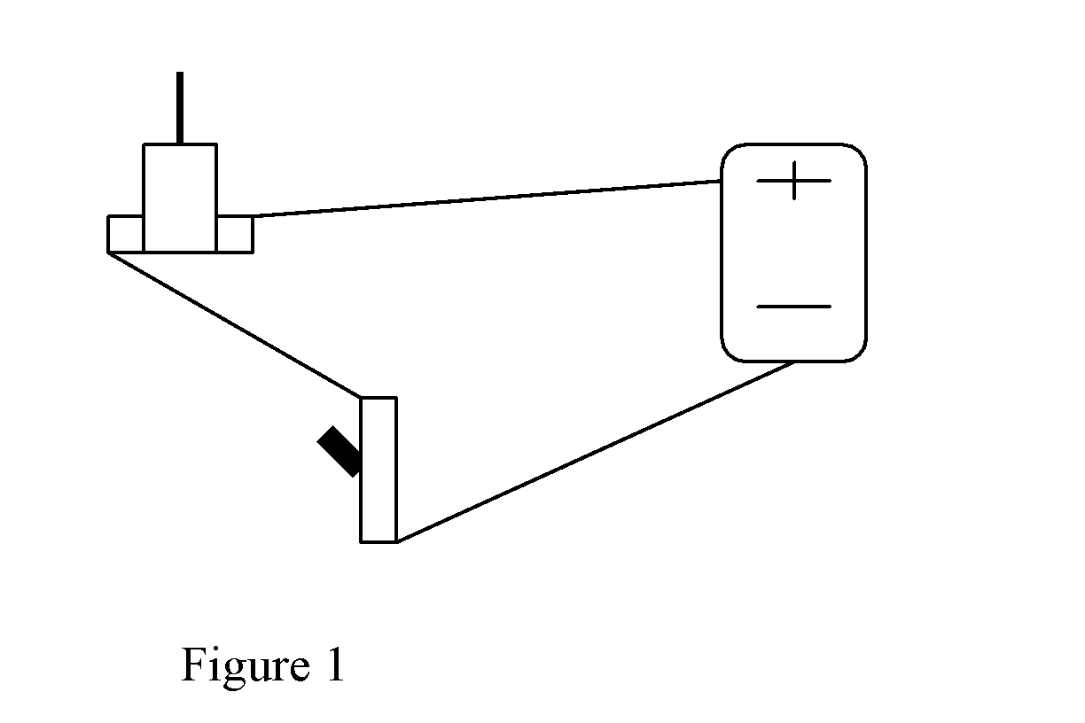

When the switch is off, the circuit is open and electricity can’t flow. When the switch is on, the circuit is closed and electricity can flow.

The rover must be assembled so that the wheels are placed at back end of the chassis and the motor stem is parallel to the rear wheel. A rubber band goes around the motor stem and rear wheel as a belt. This is the gearing system. The mechanical advantage is the ratio of the diameter of the can to the diameter of the motor stem. The greater this number, the stronger the turning force.

The variables to this design are in chassis length and width, suspension, and placement of the motor.

Procedure

- Cut a tube in half
- Cut one of the halves in half creating quarter tubes
- Poke holes in the center of 6 cups
- Using one of the cups, draw circle 6 circles on index cards.
- Cut out the 6 circles.
- Insert a cup into each side of all three of the tubes
- Trim the cups to be flush with the tubes (see figure 2)
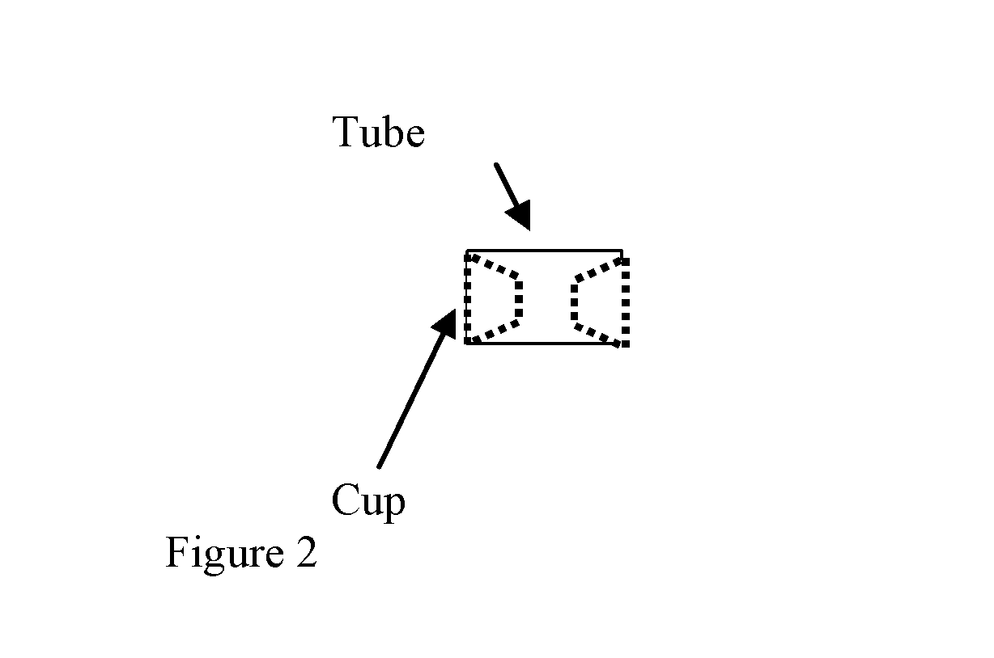
- Cover the both ends of the tube (with the cup inside) with a circle and tape
- Poke holes in the center of the circles (the holes from the circles and cups should line up
- Place three rubber bands around each of the quarter tubes
- Cut 2-3/16” dowels about 9” long.
- Cut 2-¼”” dowels about 10” long.
- Insert 1 3/16” dowel through holes of both quarter tubes (this is the rear- axle)
- Insert 1 3/16” dowel through holes the half tube (this is the front- axle)
- Cut a 6” x 4” piece of foam board
- Cut two “V”s in one of the 6” sides (see figure 3)
- Glue the foam board to the 2-¼”” dowels like the model in figure 2.
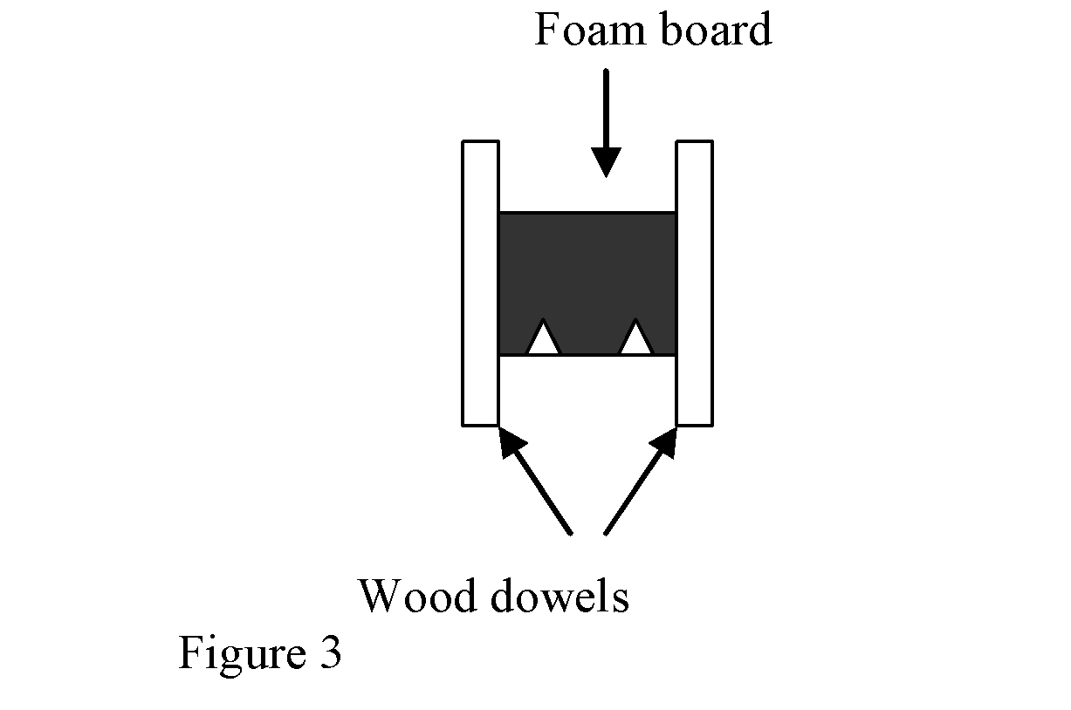
- Secure rear-axle by wrapping rubber bands on both ends of axle (on outside of chassis dowel base) – make sure quarter tubes are aligned with “v” cuts
- Secure front-axle by wrapping rubber bands on both ends of axle (on outside of chassis dowel base)
- Place tape over openings on motor
- Maintaining balance of rover, glue motor to chassis with the stem parallel to wheel axis and over the “V” (figure 4) Stem facing right makes car move one way, stem facing left makes car move the other way. Test before gluing to determine which way to glue motor so that both motors move the same direction when switches are flipped.
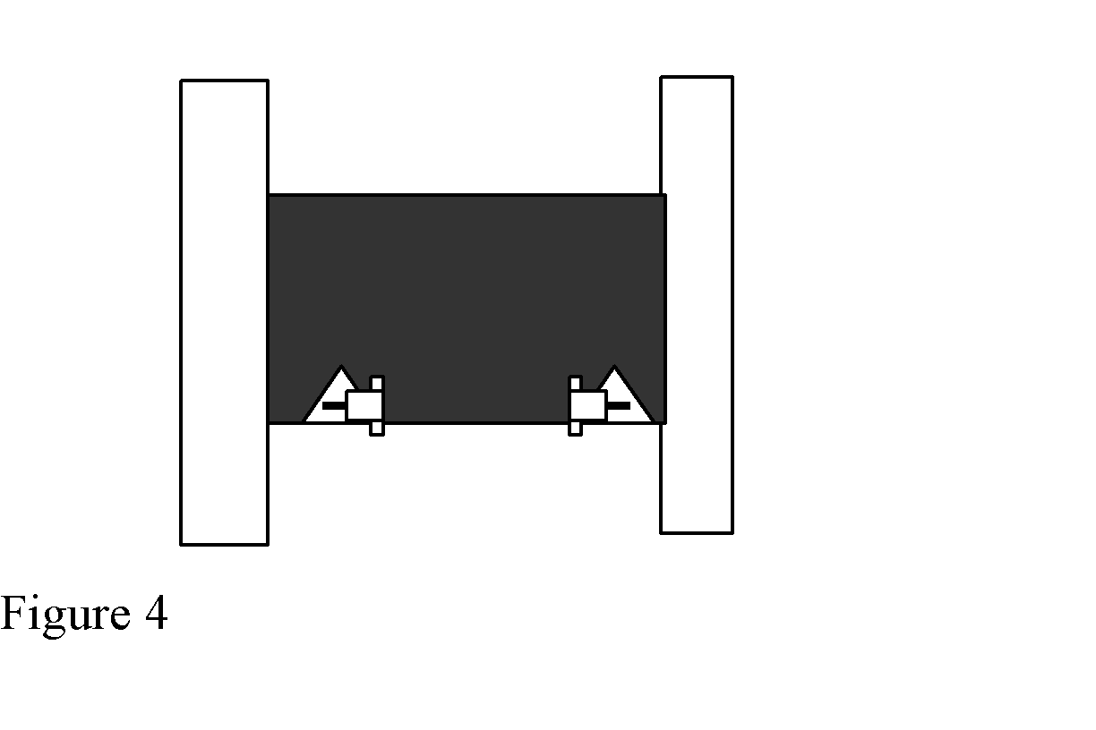
- –Cut and strip 2-4” pieces of red wire
- –Cut and strip 2-4” pieces of black wire
- –Strip the wires of a battery holder.
- –Insert into and tape red wire of battery holder wires to middle post of switch.
- –Insert into and tape black wire of battery holder wires to middle lead of switch on other side (figure 5).
- –Insert a red wire into a lead of switch on the same side as the red wire of the battery holder
- –Insert second red wire into remaining empty lead of switch on the same side as the red wire of the battery holder
- –Insert a black wire into a lead of switch on the same side as the black wire of the battery holder
- –Insert second black wire into remaining empty lead of switch on the same side as the black wire of the battery holder
- Twist ends of a red wire and black wire diagonally across from each other and insert into and tape to one lead of motor.
- –Twist ends of remaining red and black wire diagonally across from each other and insert into and tape to second lead of motor.
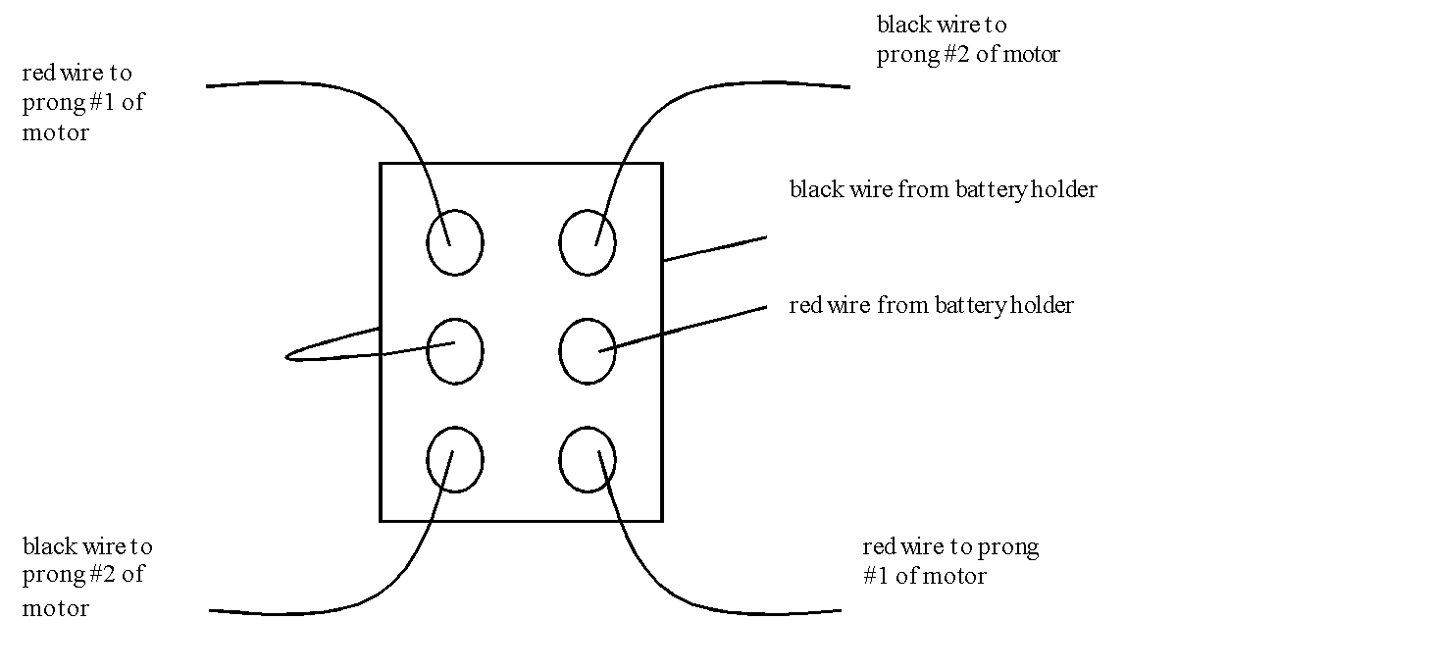

Figure 5a

Figure 5b

- The wiring for each DPDT switch is below. Note that if the wires touch, the circuit will experience a short circuit and will not work properly. Test the circuit when completed and ensure that the motor turns both ways.
- –Test circuit with batteries.
- –Connect a wire from the middle posts of 1st switch to middle posts of the second switch
- – Repeat steps 22 through 33 for a second motor
- –Test circuit with batteries.
- –Test and make necessary adjustments.

Wrap-up
End the lesson with some final discussions about what students designed/discovered. Connect their activity back to the focus question/problem, real world examples, and STEM careers.

Also include notes about any special cleanup considerations

Lesson Background for Teachers

Suggested Real-World STEM Connections
- List possible related Role Models in STEM (with details and links to more reading). Give suggestions for examples of scientists/engineers who are from underrepresented groups in STEM in related careers.
- List related real-world engineering problems and examples

Lesson Variations and Options
Include descriptions of alternative methods or ways to present things.

Explanation
Describe the background concepts and explanations behind the lesson. This can be more in depth than a teacher/instructor would actually share with students.

Key Concepts and Vocabulary
- Word 1: Grade Appropriate Definition
- Word 2: Grade Appropriate Definition

Safety Notes
- Safety instruction

